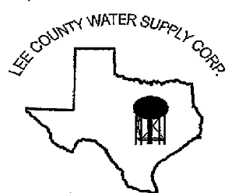

NOTICE OF MEETING
The Board of Directors of Lee County Water Supply Corporation
will have an open meeting on July 20, 2023, at 6:30 p.m. at the LCWSC Office located at
1598 S. Leon Street, Giddings, TX 78942

Agenda is as follows:

Call meeting to Order by Presiding Officer
- Pledges and Prayer
- Roll call of Directors and establish a Quorum
- Accept Director Absences
- Welcome and recognize Visitors and Guests
- Public Comments (limit to 3 minutes and one speaker per issue)
- Approval of Minutes from the Regular Monthly Meeting on June 15, 2023
- Evaluate and Discuss for action the current Identity Theft Policy
- Review of Financial Reports
- Managerial Reports:
- Monthly Recap
- Leak/Repair Log
- Water Well Level Report
- Yearly Usage Worksheet
- Budget Committee Review
- Discuss items to be included on the next monthly meeting agenda.
- Adjournment

If during the course of the meeting, the Board determines that any item covered by the agenda should be discussed in closed session as authorized by Texas Government Code, Chapter 551, the Board may convene in closed session over said item. If a closed session is held on any item in accordance with Texas Government Code Section 551, the Board will reconvene in open session to take any required action.

Date: July 17, 2023

