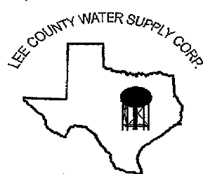
NOTICE OF MEETING
The Board of Directors of Lee County Water Supply Corporation
will have an open meeting on February 9, 2023, at 6:30 p.m.at the LCWSC Office located at
1598 S. Leon Street, Giddings, TX 78942
Agenda is as follows:
Call meeting to Order by Presiding Officer.
- Pledges and Prayer
- Roll call of Directors and establish a Quorum.
- Accept Director Absences.
- Welcome and recognize Visitors and Guests.
- Public Comments (limit to 3 minutes and one speaker per issue).
- LCWSC Employee Comment
- Approval of Minutes from the Regular Monthly Meeting on January 19, 2023
- Credential Committee Report
- Discuss and take action to pass the resolution Declaring Unopposed Candidates
- Discuss and take action to approve the Notice/Agenda for the Annual Members Meeting
- Discuss and take action on purchasing land around the Paige 3 Site
- Review of Financial Reports
- Managerial Reports:
- Monthly Recap
- Engineers Report
- Leak/Repair
- Water Well Level Report
- Yearly Usage Worksheet
- Lexington Filtration Project
- Paige Generator Project
- Country Corner Chlorination Project
- Hwy 77 TXDOT Project
- CR 405 E. Project/CR 104 & 103 Project
- Hydraulic Study/Rate Study
- New Company Trucks
- Current Capital Improvement Projects
- Review and update the Investment Policy
- Pipe Yard
- Discuss items to be included on the next monthly meeting agenda.
- Discuss combining the March 16th and March 23rd Regular Board Meeting
If during the course of the meeting the Board determines that any item covered by the agenda should be discussed in closed session as authorized by Texas Government Code, Chapter 551, the Board may convene in closed session over said item. If a closed session is held on any item in accordance with Texas Government Code Section 551, the Board will reconvene in open session to take any required action.

Date: February 6, 2023

